**Notes 7: CSS Styling through Classes**

This lesson will do the following:

1. Teach you what a **Class** is
2. How to apply a class to specific text
3. How to apply a class to a div
4. How to wrap a div around text

**Introduction to Classes**

To date we have added style to our web pages by using the Dreamweaver page properties button. We have added styling to HTML tags (Ex: H1 or P), and we have applied styling through named divs (Ex: banner or footer). In addition to these methods we may also apply styling through the use of “classes.”

Classes and IDs are the two methods we have for naming sections or elements within a web page. As you will recall, we named the major sections of our page by creating divs, which we named with IDs. IDs may only be used once on any one web page. If I name one section of the page *banner*, I cannot refer to another section of that same page as *banner* although I may use it one time on any other web page. Since we would only ever include one banner or one footer on a page, it is appropriate that we named these regions with IDs.

There are many times that a designer may wish to apply a particular style more than once on a web page. In this case the designer would create a class because classes can be used any number of times on a web page. As an example, if my page includes a number of quotes, and I wish to style these quotes differently than the basic text on the page, I can create a class that includes all the styling instructions for quotes and apply that class to each quote.

**To create a class in Dreamweaver:**

1. Click the new rule icon at the bottom of the CSS pane.

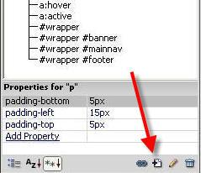

1. Change the selector type to “class”

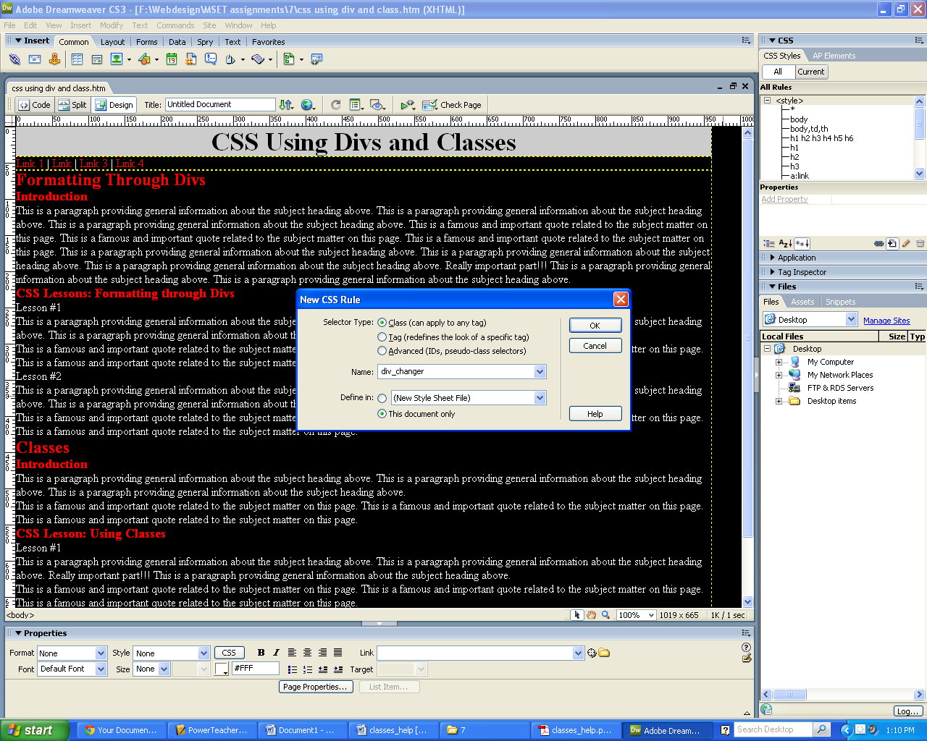

1. Enter a good name for the class **(do not use any spaces in the name**)
2. Click “OK”

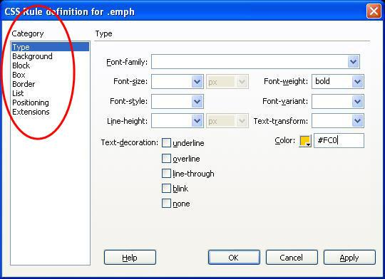

Choose properties for the class from the categories available. You can always add, remove or modify your settings later.

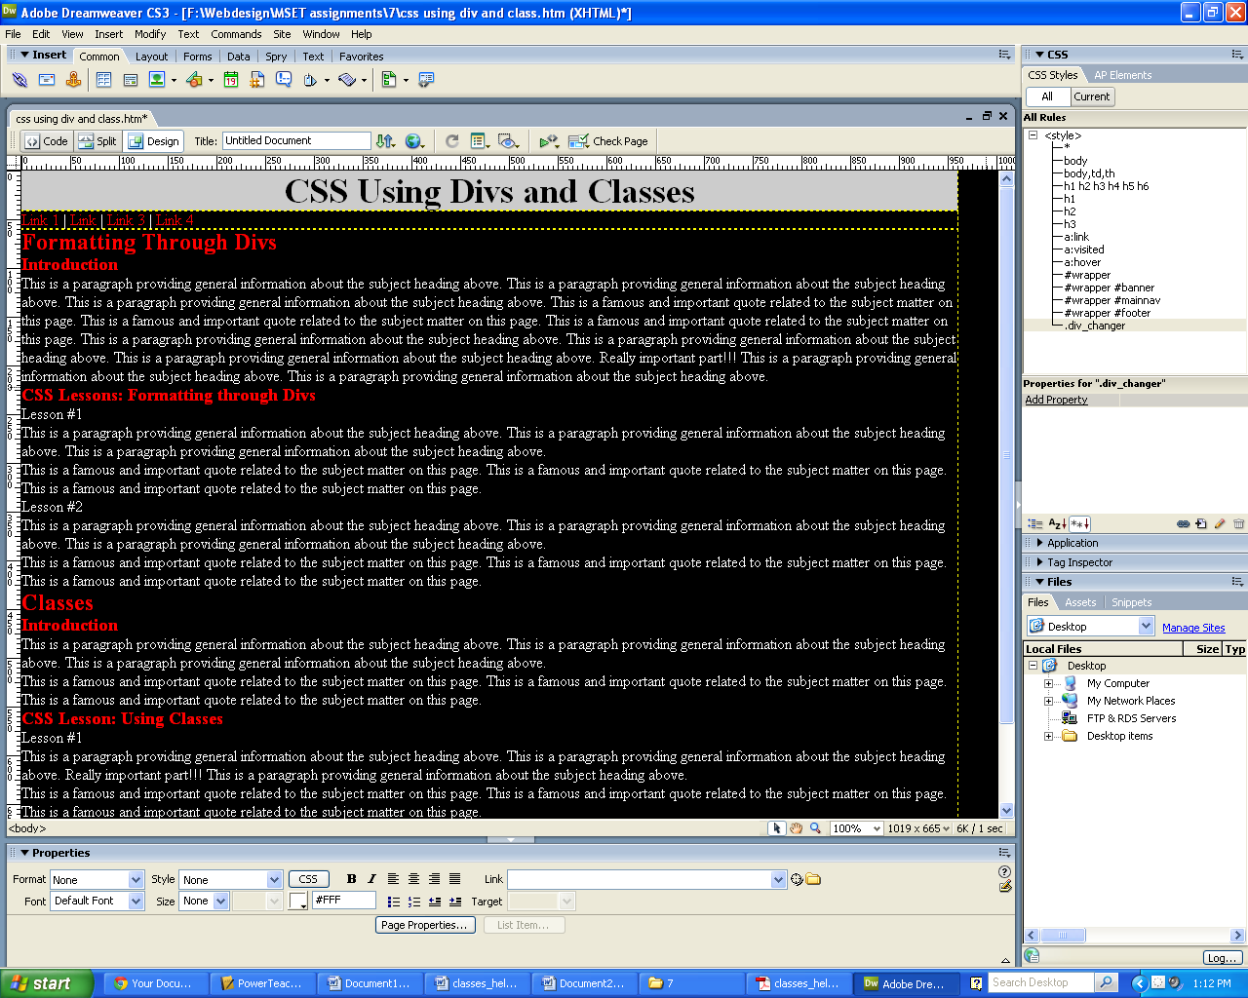

The class now appears in the CSS Style Pane.

**To apply a class to some text in your document**

1. Select the text | Choose the class from the class dropdown in the properties pane.

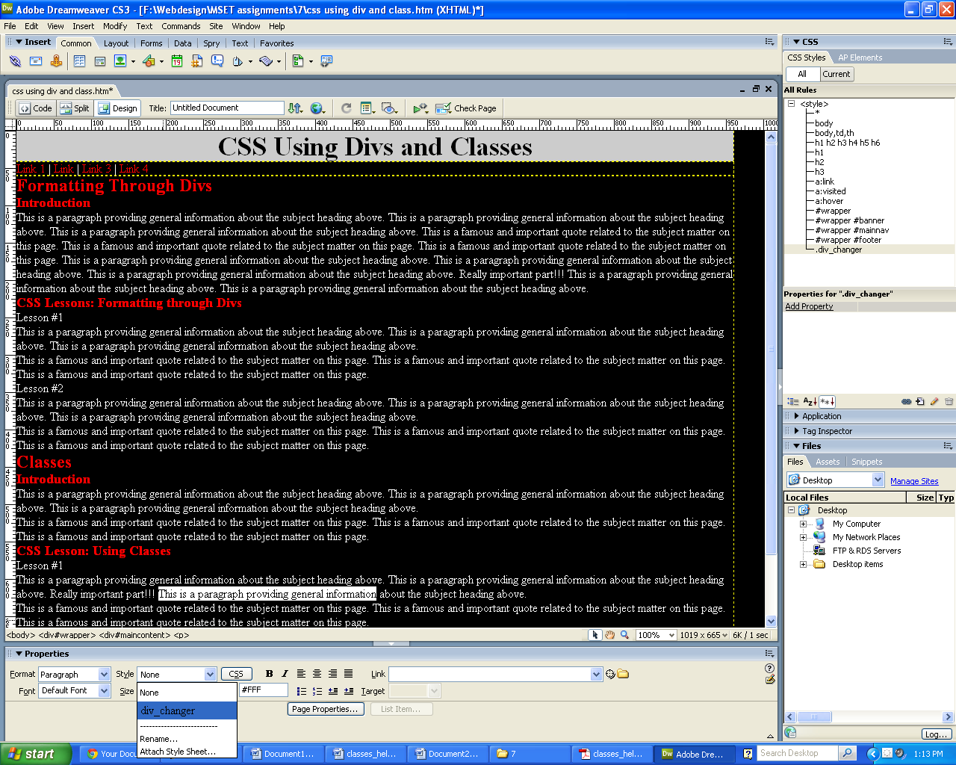

**To apply a class to a div in your document**

1. Highlight the content you wish to wrap in a div
2. Check that insert drop down reads “Wrap around selection”
3. Use the class drop down to choose “lessonbody” | OK

**Note** *– Dreamweaver will most likely not select the class you select the first time you**select it. This is a glitch in the program. You will probably need to select it a second time.*

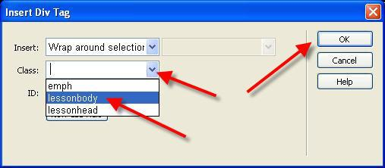

1. Apply the lessonhead and lessonbody classes to the rest of the page as appropriate.
2. To conclude this lesson, create one more class called “dropcap.” In this class the text size should be larger than the basic text, a different color, a different font face, and italicized. Apply this class to the first letter of each paragraph in each lesson body using the same method used in the “To apply a class to some text in your document” section of this document

Class Work

**1. Apply the class to one of the lesson titles as shown here:**

The document we are working with contains a series of lessons each of which has a title – Lesson 1, Lesson 2, etc. Use the techniques you just learned above to create and apply a class to the titles. Name the class “lessonhead.” Give the class:

|  |  |
| --- | --- |
| What to create: | Category (where to change it) |
| a 2 pixel borders on the top, left, and right | Border |
| a different background color | Background |
| a different text font face, font size, and color | Type |
| make the font bold | Type |
| a small top margin and wider left and right margins  (150 px should be fine) | Box |

**2. Create a class for the main body of each lesson. Name it “lessonbody.” Give the class:**

|  |  |
| --- | --- |
| What to create: | Category (where to change it) |
| a 2 pixel border on all four sides that **matches** the color of the *lessonhead* border | Border |
| a background color **different** from *lessonhead* | Background |
| a text color to compliment the background color | Type |
| left and right margins that match those of *lessonhead* | Box |
| a small bottom margin | Box |

If you try to apply the class to the paragraphs in each lesson, you will discover a problem. If you simply highlight and apply the class, it will be applied to each paragraph individually resulting in borders and margins between the paragraphs. **You must insert a div around that content**. As the div is created you can apply the lessonbody class to it.